CAUTION
Health Hazard Harmful Toxic Flammable Corrosive Explosive Oxidizing Environmental Hazard
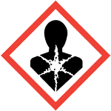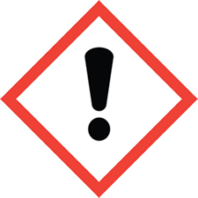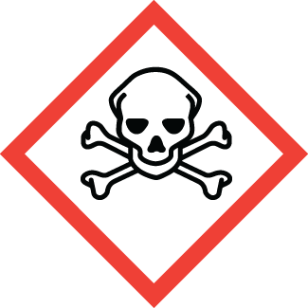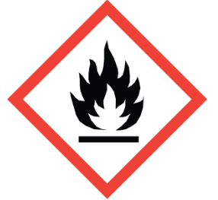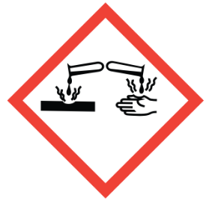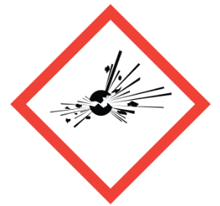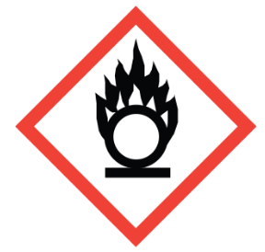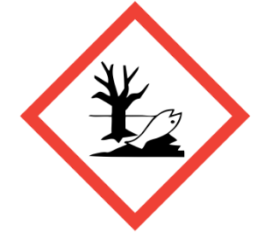
☐ ☐ ☐ ☐ ☐ ☐ ☐ ☐
POTENTIAL CHEMICAL HAZARD(S)
AUTHORIZED PERSONNEL ONLY

Minimum PPE required when handling boxes/ animals/material potentially contaminated with chemicals:
    - 1 pair nitrile gloves
    - Disposable lab coat or gown
    - Special PPE such as eye, mucous membrane and/or respiratory protection may be required based on risk
assessment or if working outside biosafety cabinet, animal transfer station (ATS) or chemical fume hood.

Chemical in Use | Hazard(s) | Additional/ Special PPE Required
SDS Location:
12/18/2019 v5.

